

Researching significant weather events: Teacher note
Scientists learn about the weather by using instruments to take measurements and make observations.
In this lesson, students will first explore the behaviour of a recorded cyclone. Students will need to interpret data provided on a cyclone tracker map. When discussing the map ensure students know how to read the key and understand lines of latitude and longitude.
Lines of latitude and longitude are used to describe the position of a country or place in the world. Lines of latitude run across the globe (from left to right) and lines of longitude run from the top of Earth to the bottom (pole to pole).
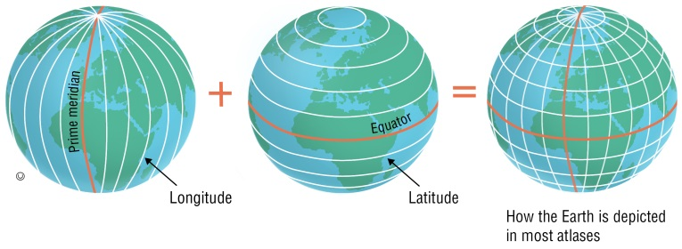
In the second activity, students will compare and contrast the behaviour of significant weather events by considering measurements and observations recorded. Students may choose to research their own significant weather events that have impacted on the Australian region or may use the summarised research provided in the supporting learning resource The behaviour of two significant weather events plus the data provided in the first activity on Severe Tropical Cyclone Marcia.
The following websites may be useful for students’ own research.
Website — Severe weather events (Australian Government, Bureau of Meteorology) http://reg.bom.gov.au/announcements/sevwx/
Website — Previous tropical cyclones (Australian Government, Bureau of Meteorology) http://www.bom.gov.au/cyclone/history/index.shtml
Cyclones — Background information
A cyclone is a violent tropical storm characterised by high-velocity winds and torrential rain swirling around an area of low pressure. Cyclones can be categorised in the following ways according to wind speed:
Category 1 — wind gusts less than 125 km/h
Category 2 — wind gusts 125 to 169 km/h
Category 3 — wind gusts 170 to 224 km/h
Category 4 — wind gusts 225 to 279 km/h
Category 5 — wind gusts of 280 km/h or greater
Each time a new cyclone develops, the Bureau of Meteorology (BOM) selects its name from a list of 104 names that alternate between male and female names. The first name for a cyclone in Australia for 2016–2017 cyclone season was Yvette.
To find out more about cyclone names, visit the website Tropical cyclone names (Australian Government, Bureau of Meteorology) http://www.bom.gov.au/cyclone/about/names.shtml.

